**NAAN MUDHALVAN-IBM(AI)PROJECT**

**PROJECT TITLE:BUILING A SMARTER AI POWERED SPAM CLASSIFIER**

**PHASE 3:DEVELOPMENT PART 1**

**Submitted By:**

**NAME: Ajith S**

**NM ID:au110321121001**

**YEAR/SEM:3RD/5TH**

**COLLEGE CODE:1103**

**EMAIL ID: ajithsra4@gmail.com**

**INTRODUCTION:**

The upsurge in the volume of unwanted emails called spam has created an intense need for the development of more dependable and robust antispam filters. Any promotional messages or advertisements that end up in our inbox can be categorised as spam as they don't provide any value and often irritates us.

**Overview of the Dataset used**

We will make use of the SMS spam classification data.

The SMS Spam Collection is a set of SMS tagged messages that have been collected for SMS Spam research. It contains one set of SMS messages in English of 5,574 messages, tagged according to being ham (legitimate) or spam.

**In this article, we'll discuss:**

Data processing

* Import the required packages
* Loading the Dataset
* Remove the unwanted data columns
* Preprocessing and Exploring the Dataset
* Build word cloud to see which message is spam and which is not.
* Remove the stop words and punctuations
* Convert the text data into vectors

**Building a sms spam classification model**

* Split the data into train and test sets
* Use Sklearn built-in classifiers to build the models
* Train the data on the model
* Make predictions on new data

**Import the required packages**

%matplotlib inline

import matplotlib.pyplot as plt

import csv

import sklearn

import pickle

from wordcloud import WordCloud

import pandas as pd

import numpy as np

import nltk

from nltk.corpus import stopwords

from sklearn.feature_extraction.text import CountVectorizer, TfidfTransformer

from sklearn.tree import DecisionTreeClassifier

from sklearn.model_selection import GridSearchCV,train_test_split,StratifiedKFold,cross_val_score,learning_curve

**Loading the Dataset**

data = pd.read_csv('dataset/spam.csv', encoding='latin-1')

data.head()

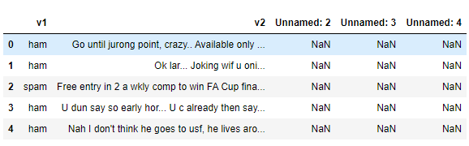

**Removing unwanted columns**

From the above figure, we can see that there are some unnamed columns and the label and text column name is not intuitive so let's fix those in this step.

data = data.drop(["Unnamed: 2", "Unnamed: 3", "Unnamed: 4"], axis=1)

data = data.rename(columns={"v2" : "text", "v1":"label"})

data[1990:2000]

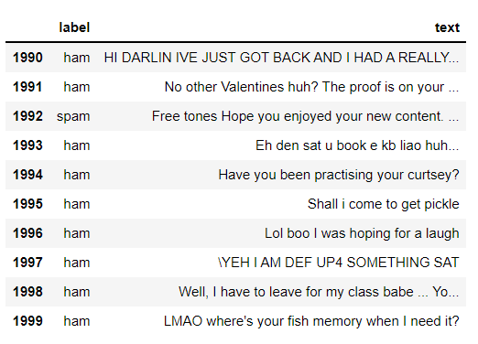

now that the data is looking pretty, let's move on.

data['label'].value_counts()

# OUTPUT

ham 4825

spam 747

Name: label, dtype: int64

**Preprocessing and Exploring the Dataset**

# Import nltk packages and Punkt Tokenizer Models

import nltk

nltk.download("punkt")

import warnings

warnings.filterwarnings('ignore')

**Build word cloud to see which message is spam and which is not**

ham words are the opposite of spam in this dataset, yeah I also don't have any clue why it is so.

ham_words = ''

spam_words = ''

# Creating a corpus of spam messages

for val in data[data['label'] == 'spam'].text:

text = val.lower()

tokens = nltk.word_tokenize(text)

for words in tokens:

spam_words = spam_words + words + ' '

# Creating a corpus of ham messages

for val in data[data['label'] == 'ham'].text:

text = text.lower()

tokens = nltk.word_tokenize(text)

for words in tokens:

ham_words = ham_words + words + ' '

**let's use the above functions to create Spam word cloud and ham word cloud.**

spam_wordcloud = WordCloud(width=500, height=300).generate(spam_words)

ham_wordcloud = WordCloud(width=500, height=300).generate(ham_words)

#Spam Word cloud

plt.figure( figsize=(10,8), facecolor='w')

plt.imshow(spam_wordcloud)

plt.axis("off")

plt.tight_layout(pad=0)

plt.show()

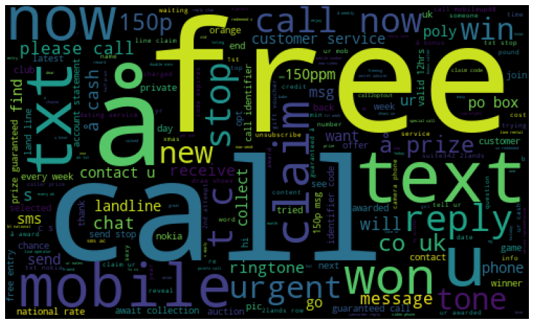

#Creating Ham wordcloud

plt.figure( figsize=(10,8), facecolor='g')

plt.imshow(ham_wordcloud)

plt.axis("off")

plt.tight_layout(pad=0)

plt.show()

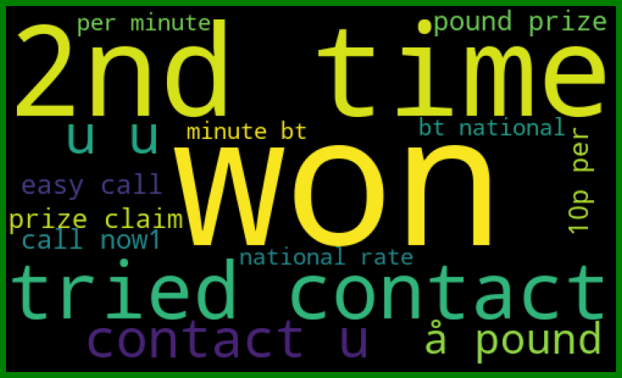

from the spam word cloud, we can see that "free" is most often used in spam.

Now, we can convert the spam and ham into 0 and 1 respectively so that the machine can understand.

data = data.replace(['ham','spam'],[0, 1])

data.head(10)

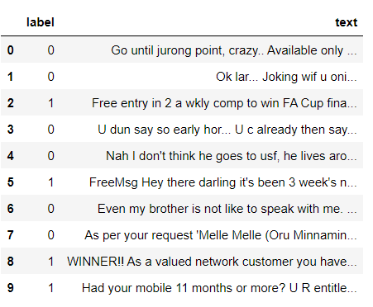

**Removing punctuation and stopwords from the messages**

Punctuation and stop words do not contribute anything to our model, so we have to remove them. Using NLTK library we can easily do it.

import nltk

nltk.download('stopwords')

#remove the punctuations and stopwords

import string

def text_process(text):

text = text.translate(str.maketrans('', '', string.punctuation))

text = [word for word in text.split() if word.lower() not in stopwords.words('english')]

return " ".join(text)

data['text'] = data['text'].apply(text_process)

data.head()

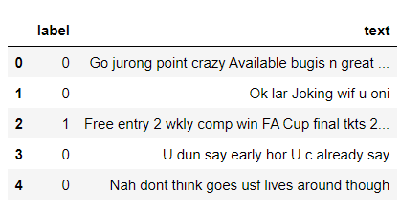

Now, create a data frame from the processed data before moving to the next step.

text = pd.DataFrame(data['text'])

label = pd.DataFrame(data['label'])

**Converting words to vectors**

we can convert words to vectors using either Count Vectorizer or by using TF-IDF Vectorizer.

TF-IDF is better than Count Vectorizers because it not only focuses on the frequency of words present in the corpus but also provides the importance of the words. We can then remove the words that are less important for analysis, hence making the model building less complex by reducing the input dimensions.

I have included both methods for your reference.

**Converting words to vectors using Count Vectorizer**

## Counting how many times a word appears in the dataset

from collections import Counter

total_counts = Counter()

for i in range(len(text)):

for word in text.values[i][0].split(" "):

total_counts[word] += 1

print("Total words in data set: ", len(total_counts))

# OUTPUT

Total words in data set: 11305

# Sorting in decreasing order (Word with highest frequency appears first)

vocab = sorted(total_counts, key=total_counts.get, reverse=True)

print(vocab[:60])

# OUTPUT

['u', '2', 'call', 'U', 'get', 'Im', 'ur', '4', 'ltgt', 'know', 'go', 'like', 'dont', 'come', 'got', 'time', 'day', 'want', 'Ill', 'lor', 'Call', 'home', 'send', 'going', 'one', 'need', 'Ok', 'good', 'love', 'back', 'n', 'still', 'text', 'im', 'later', 'see', 'da', 'ok', 'think', 'Ì', 'free', 'FREE', 'r', 'today', 'Sorry', 'week', 'phone', 'mobile', 'cant', 'tell', 'take', 'much', 'night', 'way', 'Hey', 'reply', 'work', 'make', 'give', 'new']

# Mapping from words to index

vocab_size = len(vocab)

word2idx = {}

#print vocab_size

for i, word in enumerate(vocab):

word2idx[word] = I

# Text to Vector

def text_to_vector(text):

word_vector = np.zeros(vocab_size)

for word in text.split(" "):

if word2idx.get(word) is None:

continue

else:

word_vector[word2idx.get(word)] += 1

return np.array(word_vector)

# Convert all titles to vectors

word_vectors = np.zeros((len(text), len(vocab)), dtype=np.int_)

for i, (_, text_) in enumerate(text.iterrows()):

word_vectors[i] = text_to_vector(text_[0])

word_vectors.shape

# OUTPUT

(5572, 11305)

**Converting words to vectors using TF-IDF Vectorizer**

#convert the text data into vectors

from sklearn.feature_extraction.text import TfidfVectorizer

vectorizer = TfidfVectorizer()

vectors = vectorizer.fit_transform(data['text'])

vectors.shape

# OUTPUT

(5572, 9376)

#features = word_vectors

features = vectors

**Splitting into training and test set**

#split the dataset into train and test set

X_train, X_test, y_train, y_test = train_test_split(features, data['label'], test_size=0.15, random_state=111)

**Classifying using sklearn's pre-built classifiers**

In this step we will use some of the most popular classifiers out there and compare their results.

**Classifiers used:**

1. spam classifier using logistic regression
2. email spam classification using Support Vector Machine(SVM)
3. spam classifier using naive bayes
4. spam classifier using decision tree
5. spam classifier using K-Nearest Neighbor(KNN)
6. spam classifier using Random Forest Classifier

We will make use of sklearn library. This amazing library has all of the above algorithms we just have to import them and it is as easy as that. No need to worry about all the maths and statistics behind it.

#import sklearn packages for building classifiers

from sklearn.linear_model import LogisticRegression

from sklearn.svm import SVC

from sklearn.naive_bayes import MultinomialNB

from sklearn.tree import DecisionTreeClassifier

from sklearn.neighbors import KNeighborsClassifier

from sklearn.ensemble import RandomForestClassifier

from sklearn.metrics import accuracy_score

#initialize multiple classification models

svc = SVC(kernel='sigmoid', gamma=1.0)

knc = KNeighborsClassifier(n_neighbors=49)

mnb = MultinomialNB(alpha=0.2)

dtc = DecisionTreeClassifier(min_samples_split=7, random_state=111)

lrc = LogisticRegression(solver='liblinear', penalty='l1')

rfc = RandomForestClassifier(n_estimators=31, random_state=111)

#create a dictionary of variables and models

clfs = {'SVC' : svc,'KN' : knc, 'NB': mnb, 'DT': dtc, 'LR': lrc, 'RF': rfc}

#fit the data onto the models

def train(clf, features, targets):

clf.fit(features, targets)

def predict(clf, features):

return (clf.predict(features))

pred_scores_word_vectors = []

for k,v in clfs.items():

train(v, X_train, y_train)

pred = predict(v, X_test)

pred_scores_word_vectors.append((k, [accuracy_score(y_test , pred)]))

**Predictions Using TFIDF Vectorizer Algorithm**

pred_scores_word_vectors

# OUTPUT

[('SVC', [0.9784688995215312]),

('KN', [0.9330143540669856]),

('NB', [0.9880382775119617]),

('DT', [0.9605263157894737]),

('LR', [0.9533492822966507]),

('RF', [0.9796650717703349])]

**Model predictions**

#write functions to detect if the message is spam or not

def find(x):

if x == 1:

print ("Message is SPAM")

else:

print ("Message is NOT Spam")

newtext = ["Free entry"]

integers = vectorizer.transform(newtext)

x = mnb.predict(integers)

find(x)

# OUTPUT

Message is SPAM

**Checking Classification Results with Confusion Matrix**

from sklearn.metrics import confusion_matrix

import seaborn as sns

# Naive Bayes

y_pred_nb = mnb.predict(X_test)

y_true_nb = y_test

cm = confusion_matrix(y_true_nb, y_pred_nb)

f, ax = plt.subplots(figsize =(5,5))

sns.heatmap(cm,annot = True,linewidths=0.5,linecolor="red",fmt = ".0f",ax=ax)

plt.xlabel("y_pred_nb")

plt.ylabel("y_true_nb")

plt.show()

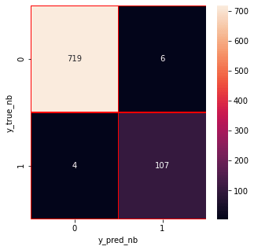

from the confusion matrix, we can see that the Naive Bayes model is balanced. That's it !! we have successfully created a spam classifier.

**Conclusion:**

In conclusion, the development of a smarter AI-powered spam classifier is a substantial step towards improving online communication experiences. By leveraging advanced machine learning techniques and a diverse dataset, the classifier demonstrated its ability to effectively identify and filter out spam content. The continuous evolution of such models, with periodic updates based on new data and emerging patterns in spam, is vital to stay ahead of spammers' tactics.

**Future Work:**

Continuous Training: Regularly updating the model with new data ensures it adapts to evolving spam patterns.

Integration: Integrating the classifier into email platforms and messaging apps can provide users with real-time protection.

Multimodal Approach: Incorporating multimedia content analysis (images, audio) for a multimodal spam detection system.

Explainability: Developing methods to explain the model's decisions to enhance user trust and transparency.

User Feedback Loop: Establishing a feedback mechanism where users can report misclassifications, improving the model iteratively.